**Mathematics Methods Unit 3 2019**

**Investigation 2: Applications of Integration:**

**Part C In-class validation Time allowed 50 minutes**

**Name: ______________________________________ Marks: ________ / 30**

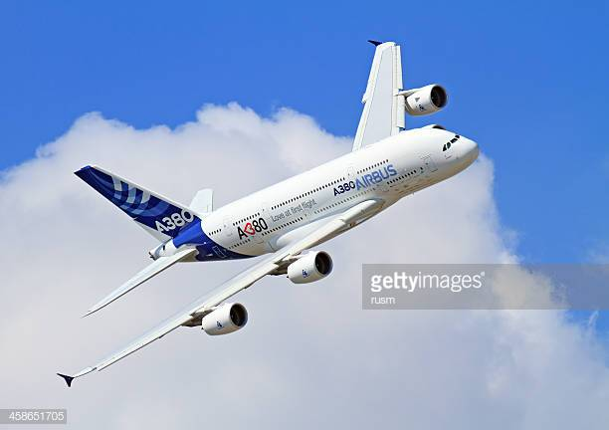

The Airbus A380 plane is assembled in Toulouse, France from sections manufactured in France, Germany, Spain & the United Kingdom and these are transported there by specialised road and water methods, though some parts are moved by the [A300-600ST *Beluga*](https://en.wikipedia.org/wiki/Airbus_Beluga) transport aircraft.

[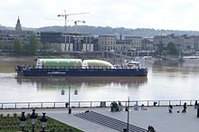](https://en.wikipedia.org/wiki/File:A380_transport_Port_de_Bordeaux.jpg)

A380 components on a barge

In order to avoid damage from direct handling, parts are secured in custom made framework.

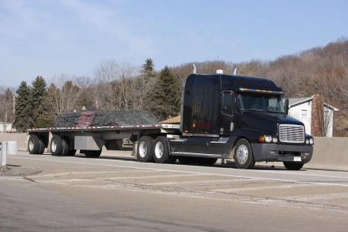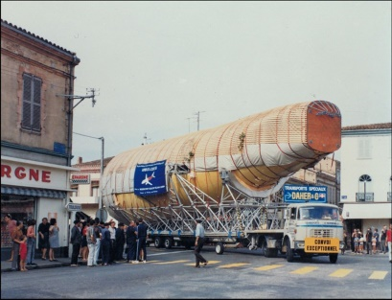

Transportation of a large part through public streets a typical flatbed truck

The real-life scenario being presented to you involves the arrangements for transportation of two plane parts on flatbed trucks: a hemispherical nose cone and a longer and flatter irregular shape.

Your task is to assess what size of flatbed truck will be needed to transport these parts separately. You may need to make assumptions along the way. These should be explained in Question 3.

In both cases the mass of the parts is uniformly spread.

**Question 1 [ 11,3 = 14 marks]**

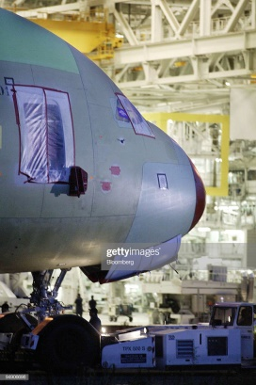Assuming the nose cone of the Airbus A380 is a hemisphere with a radius of 5 metres, what length of tray on a flatbed truck would be needed to transport it to a port or factory:

**a)** in an upright position in an appropriate custom framework to hold it:

**i)** with an overhang allowed?

Show your reasoning in detail.

**ii)** without an overhang ?

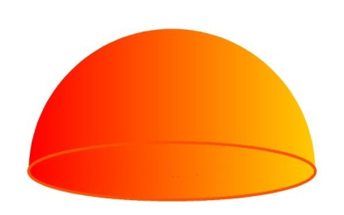**b)** in a flat position ?

**i)** with an overhang allowed **ii)** without an overhang ?

**Question 2 [ 1,8,2 = 11 marks]**

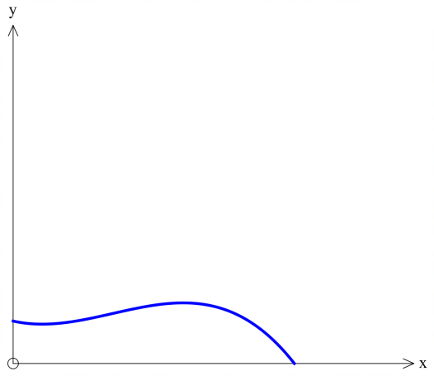

A section of plane takes shape based on the formula

$$y= -0.0006x^{3}+0.019x^{2}-0.1x+2$$

with both axes measured in metres.

You will need to assume the width of the item is uniform and

conforms to the width of the tray of the truck.

**a)** What is the minimum length of tray required to accommodate

this piece of aircraft positioned as shown if an overhang is not allowed ?

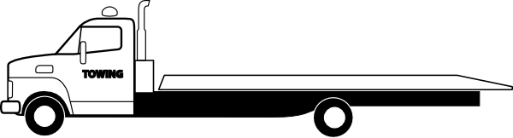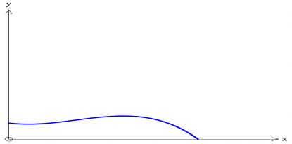

**b)** What is the minimum length of tray required if an overhang is allowed?

**c)** How would this be affected if the item was placed the other way round, ie the more contoured end facing the cab of the truck ?

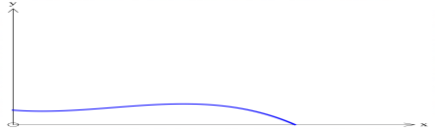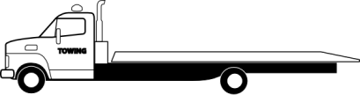

**Question 3 [ 5 marks]**

List five assumptions you have made in the process of answering these questions, or further considerations that may have to be taken into account.

END OF PAPER